Solway, Kevin (from theabsolute.net website)
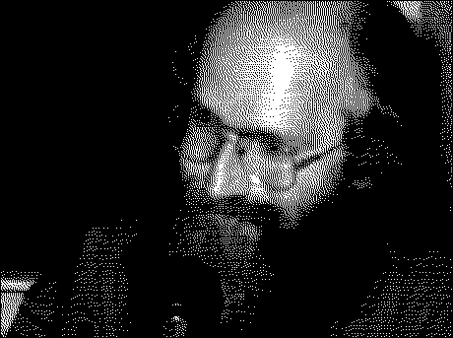
Born in 1961 and brought-up on the small island of Guernsey, about 120km south of England, but within sight of France. At age 11, his father, who was now divorced, married an Australian nurse who was working on the island at the time and migrated to Australia.
At age 17 studied first-year Science at The University of Queensland and then spent a further three years at The Department of Forestry at the Australian National University in Canberra to earn a BSc (Forestry) c1981.
Each summer vacation he worked as a gang member for the Forests Department of Western Australia in and around the town of Margaret River.
When finished his degree he worked as the assistant manager of a private forestry company for 6 months in WA, then went fox hunting for skins with an ex-New Zealand deer hunter who was working as a tree-feller for the company at the time. After one season of foxes he sold Encyclopaedia Britannica in Perth for a few months. Age was then 22. After six months he sold virtually everything and headed back to Queensland. For the next 8 or so years he lived in Brisbane. For the last few years he has been living in a small town called Maleny, in the hills about 120km North of Brisbane.

